FSD for Add Case in SPA.

* User logs in.
* If user role = ‘SPA’ and user subrole in (‘CS’, ‘IC’), allow “ADD CASE” BUTTON in the Navigation. Else disable the “ADD CASE” button.
* If the user click “ADD CASE”,
* Insert values in Temp table and create BP
* ~~Take the first case number with u_case_Status = ‘FREE’ and update u_case_status =’BOOKED’  
  If no such case number exists create a new case with U_case_status=’BOOKED’~~
* ~~If due to some issues and the case is not confirmed, change u_case_status from ‘BOOKED’ TO ‘FREE’.~~
* Set OCRD.OWNERIDNUM = user’s branch (ohem.branch)  
  E.g. “JJ”
* Set OCRD.CARDCODE = YYXXXXXXXX  
  E.g. “1500001298” where 15 is the year followed by running number with 8 digits.  
  Set OCRD.CARDNAME = “JJ/1500001298/SPA” where JJ is the branch code, followed by OCRD.CARDCODE and the application type.

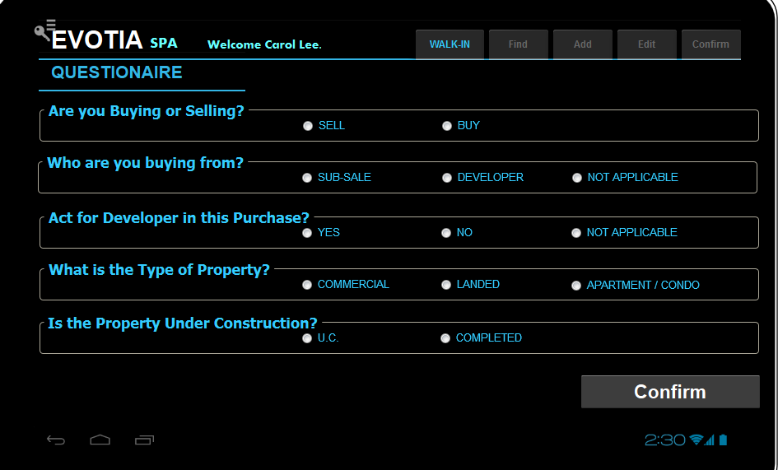

* If user click “SELL”,
  + Set OCRD. QryGroup3 =’Y’.
  + Set OCRD. U_VNDR_RP_FIRM =”Y’
  + Set OCRD. U_VNDR_RP_LWYR=”Y”
* If user click “BUY”,
  + Set OCRD. QryGroup4=’Y’.
  + Set OCRD.U_PURCH_RP_FIRM=”Y”
  + Set OCRD.U_PURCH_RP_LWYR=”Y”

­­­­­­­­­­­­­­­­­­­­­­­­­­­­­­­­­­­­­­­­­________________________________________________________________________

* If user chose BUY, user must choose “SUB-SALE” or “DEVELOPER”.
* If user click “SUB-SALE”,
  + Set OCRD. QryGroup6=’Y’.
* If user click “DEVELOPER”,
  + Set OCRD. QryGroup5=’Y’.

_________________________________________________________________________

* If user chose BUY, user must choose “YES” or “NO”.
* If user click “YES”,
  + Set OCRD. QryGroup17=’Y’

_________________________________________________________________________

* If User Click Commercial,
  + Set OCRD. QryGroup7=’Y’.
* If User Click Landed,
  + Set OCRD. QryGroup8=’Y’.
* If User Click Apt/Condo,
  + Set OCRD. QryGroup9=’Y’.

__________________________________________________________________________

* If User Click UC,
  + Set OCRD. QryGroup10=’Y’.
* If User Click Completed,
  + 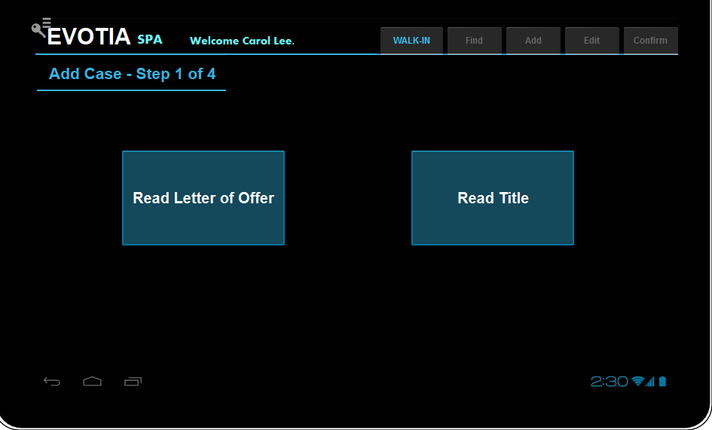Set OCRD. QryGroup11=’Y’.

|  |  |  |  |  |  |  |  |  |  |  |  |  |  |  |  |  |  |  |  |  |  |  |  |  |  |  |  |  |
| --- | --- | --- | --- | --- | --- | --- | --- | --- | --- | --- | --- | --- | --- | --- | --- | --- | --- | --- | --- | --- | --- | --- | --- | --- | --- | --- | --- | --- |
|  |  |  |  |  |  |  |  |  |  |  |  |  |  |  |  |  |  |  |  |  |  |  |  |  |  |  |  |  |
|  |  |  |  |  |  |  |  |  |  |  |  |  |  |  |  |  |  |  |  |  |  |  |  |  |  |  |  |  |
|  |  | **Add Case Step 1 of 4** | | | | |  |  |  |  |  | **Chose Document to Read** | | | | | |  |  |  |  |  |  |  |  |  |  |  |
|  |  |  |  |  |  |  |  |  |  |  |  |  |  |  |  |  |  |  |  |  |  |  |  |  |  |  |  |  |
|  |  |  |  |  |  |  |  |  |  |  |  |  |  |  |  |  |  |  |  |  |  |  |  |  |  |  |  |  |
|  |  | **Item code** | | | | | | | | | | | **Item Name** | | | | | | | | | | | | | |  |  |
|  |  | 1000007 | | | | | | | | | | | Title | | | | | | | | | | | | | |  |  |
|  |  | 2000 | | | | | | | | | | | Letter of offer from OCBC | | | | | | | | | | | | | |  |  |
|  |  |  |  |  |  |  |  |  |  |  |  |  |  |  |  |  |  |  |  |  |  |  |  |  |  |  |  |  |
|  |  |  |  |  |  |  |  |  |  |  |  |  |  |  |  |  |  |  |  |  |  |  |  |  |  |  |  |  |
|  |  | Choose File | | |  |  |  |  |  |  |  |  |  |  |  |  |  |  |  |  |  |  |  |  |  |  |  |  |
|  |  |  | | | | | | | | | | … |  |  |  |  |  |  |  |  |  |  |  |  |  |  |  |  |
|  |  |  |  |  |  |  |  |  |  |  |  |  |  |  |  |  |  |  |  |  |  |  |  |  |  |  |  |  |
|  |  |  |  |  | **OK** | | | |  |  |  |  |  | **Cancel** | | | | |  |  |  |  |  |  |  |  |  |  |
|  |  |  |  |  |  |  |  |  |  |  |  |  |  |  |  |  |  |  |  |
|  |  |  |  |  |  |  |  |  |  |  |  |  |  |  |  |  |  |  |  |  |  |  |  |  |  |  |  |  |
|  |  |  |  |  |  |  |  |  |  |  |  |  |  |  |  |  |  |  |  |  |  |  |  |  |  |  |  |  |

* If user click Choose Document to Read button, show the list of Items in the List View
* SELECT T0.[ItemCode], T0.[ItemName] FROM OITM T0 WHERE (T0.[ItemName] like '%Letter of Offer%' and not (T0.[U_RELATED_BANK] is null)) or (T0.[ItemName] like '%Title')  
  union   
  Select null, “Other Bank Letter of Offer”
* If user select from one of the item is the list and select file from local folder.
* User clicks OK Button: Call Web service to transfer file to server and read the file with the selected item code. Program to save the item code selected by user.

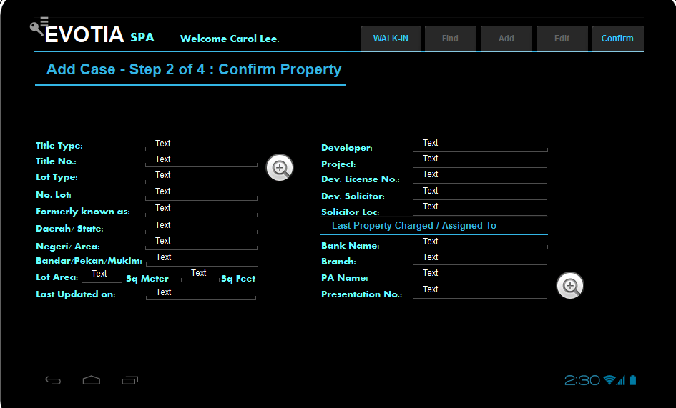

* Previous web service update the scan results in selected fields.
* Users need to choose / update manually for fields not captured.
* Developer:   
  SELECT T0.[Code], T0.[U_NAME] FROM [dbo].[@AE_RELATEDPARTY] T0 WHERE T0.[U_DEVELOPER] ='Y'  
  Mandatory if user chooses clicked “DEVELOPER” earlier.
* Project:  
  select Prjcode, PrjName from oprj p inner join [@AE_RELATEDPARTY] c where p. [U_DEVELOPER] = c.code and p.active=’Y’ or p.prjcode in (‘I’, ‘NP’)  
  User to choose from the list. Mandatory.
* Solicitor:   
  SELECT T0.[Code], T0.[U_NAME] FROM [dbo].[@AE_RELATEDPARTY] T0 WHERE T0.[U_SOLICITOR] ='Y'  
  User to choose from the list.
* Bank:   
  SELECT T0.[Code], T0.[U_NAME] FROM [dbo].[@AE_RELATEDPARTY] T0 WHERE T0.[U_BANK] ='Y'  
  User to choose from the list.
* User clicks Confirm to save.  
  Program to check if title type, title no, lot type and lot no exists in open case.
* If exists, pull out the existing record with “List of Case”.
* Do not allow case to proceed if list of property exists.  
  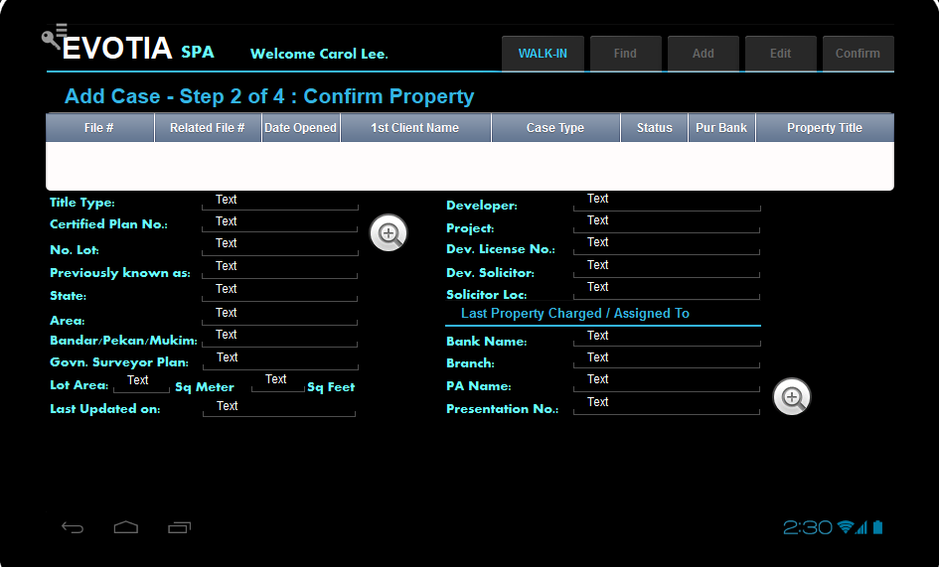

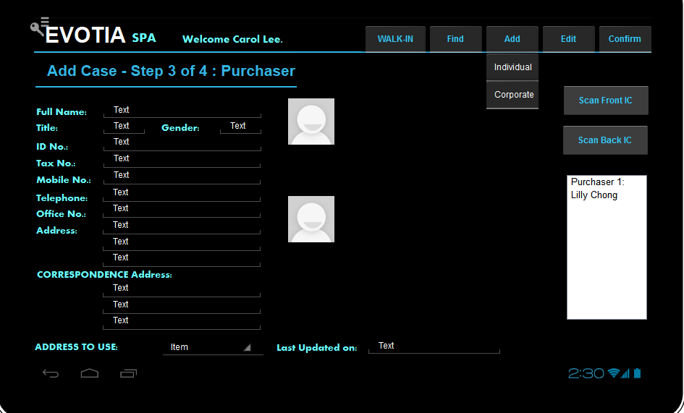

* ***User choose “Add Individual or Corporate”.
* If User choose “Corporate”:

SELECT T0.[Code], T0.[U_NAME] FROM [dbo].[@AE_RELATEDPARTY] T0 WHERE T0.[IDTYPE]=’corporate’ (prompt the popup list)  
Scan IC buttons will be dimmed off.  
User to choose from the list.

update the

* If User choose “Individual”  
  User click read front IC.   
  Call up the read template for Front IC.  
  Transfer file to folder in server.  
  Update information from the scan results to case.
* User clicks read back IC.   
  Call up the read template for back IC.  
  Transfer file to folder in server.  
  Update information from the scan results to case.
* User updates details.

* User click confirm.
* Pop up screen to ask if user wants to add another Purchaser.
* If yes go back to ***.
* Allow to add up to 4 Purchasers.
* If no go back to next screen.
* This step will create @AE_RELATEDPARTY records with IDTYPE=’INDIVIDUAL’
* UPDATE OCRD.U_PURCH_RP_CODE1 TO OCRD. U_PURCH_RP_CODE4 with the respective records created.

Update OCRD.U_ PURCH_RP_ID1 TO OCRD.U_ PURCH_RP_ID4 with the [@AE_RELATEDPARTY.U_ IDNO_F1]

Update OCRD.U_ PURCH_RP_NAME1 TO OCRD.U_ PURCH_RP_NAME4 with the [@AE_RELATEDPARTY.U_NAME]

Update OCRD.U_ PURCH_RP_TAX1 TO OCRD.U_ PURCH_RP_TAX4 with the [@AE_RELATEDPARTY.U_ TAXNOFORMAT1]

Update OCRD.U_PURCH_CONTACT1 TO OCRD.U_PURCH_CONTACT4 with the [@AE_RELATEDPARTY.U_ CONTACT_MOBILE]

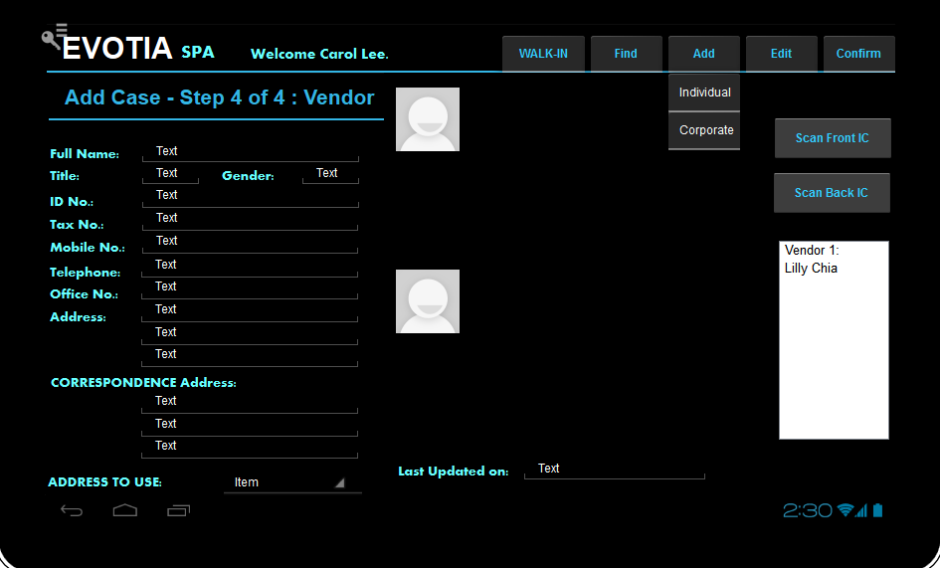

* Insert into Related party table ( if 4 vendors, insert 4 records )
* Same as Purchaser, but UPDATE OCRD. U_VNDR_RP_CODE1 TO OCRD. U_VNDR_RP_CODE4 with the respective records created.
* Update OCRD.U_ VNDR _RP_ID1 TO OCRD.U_ VNDR _RP_ID4 with the   
  [@AE_RELATEDPARTY.U_ IDNO_F1]
* Update OCRD.U_ VNDR _RP_NAME1 TO OCRD.U_ VNDR _RP_NAME4 with the [@AE_RELATEDPARTY.U_NAME]
* Update OCRD.U_ VNDR _RP_TAX1 TO OCRD.U_ VNDR _RP_TAX4 with the [@AE_RELATEDPARTY.U_ TAXNOFORMAT1]
* Update OCRD.U_ VNDR _CONTACT1 TO OCRD.U_ VNDR _CONTACT4 with the [@AE_RELATEDPARTY.U_ CONTACT_MOBILE]
* Create case and save the scan files to the respective links.
* Duplicate the exact ocrd record, but append a “C” to the ocrd.cardcode.
* Set OCRD.CARDCODE = YYXXXXXXXXC  
  E.g. “15-00001298C” where 15 is the year followed by running number with 8 digits.

Create a sales quotation under OCRD.CARDCODE = YYXXXXXXXX  
with the items selected by stored procedure.

1. Create BP
2. Create another BP ( duplicate the BP append C at the end )
3. Create Sales quotation

Exec getSPAProcessFlow

@currentSeq numeric

,@projectCode varchar(20)

, @buy varchar(1)

, @sell varchar(1)

,@developer varchar(1)

,@subsale varchar(1)

,@commercial varchar(1)

,@landed varchar(1)

,@apt varchar(1)

,@underconstruction varchar(1)

,@completed varchar(1)

,@charged varchar(1)

,@free varchar(1)

,@individualTitle varchar(1)

,@stratatitle varchar(1)

,@mastertitle varchar(1)

,@actfordeveloper varchar(1)

for now use the following:

SELECT T0.[ItemCode], T0.[ItemName], T0.[U_INT_CASE_SEQ] as [INTNO], T1.TrnspName , t2.ItmsGrpNam, T0.U_DOCUMENT_BY, T0.u_start_status, T0.U_FAIL_CLOSE

FROM OITM T0

INNER JOIN OSHP T1 ON T0.[ShipType] = T1.[TrnspCode]

inner join oitb t2 on t0.ItmsGrpCod = t2.ItmsGrpCod

WHERE T0.[QryGroup3] ='Y' --[SPA - BUY]

and T0.[QryGroup5] ='Y' --[SPA - DEVELOPER SALES]

and T0.[QryGroup9] ='Y' --[PROPERTY - APT]

and T0.[QryGroup10] ='Y' --[PROPERTY - UNDER CONSTRUCTION]

ORDER BY T0.[U_INT_CASE_SEQ]